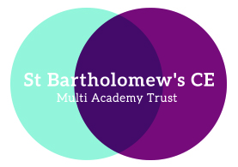


St Bartholomew’s Breakfast and Afterschool Booking Form

St Bartholomew’s CE Primary School, Sedgley Road, Penn,
Wolverhampton, WV4 5LG
Tel: 01902 558655

email: stbartholomewsprimaryschool@wolverhampton.gov.uk

BOOKING FORM: Summer 2021
Please complete and return the booking form before your child/ren start attending the provision.

Child’s Name: Class:

I require the following provision every week:

Day | Breakfast Club  £4.60 | Afterschool Club until 4.30pm  £5.50 | Afterschool Club until 6pm  £7.50
Monday

Tuesday

Wednesday

Thursday

Friday

Parent/Carer Name:

Signature:

Date:

